**Program:**

a=int(input())

t=1

s=0

for i in range(a)

s+=t

t=t*10+1

print(s)

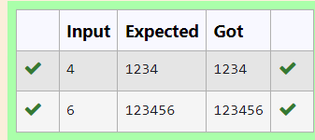

**Ex. No. : 4.8 Date: 13.04.24**

**Register No.: 231801123 Name: Pavithra S**

**Prime Checking**

Write a program that finds whether the given number N is Prime or not. If the number is prime, the program should return 2 else it must return 1.

Assumption: 2 <= N <=5000, where N is the given number.

Example1: if the given number N is 7, the method must return 2

Example2: if the given number N is 10, the method must return 1

**For example:**

| **Input** | **Result** |
| --- | --- |
| 7 | 2 |
| 10 | 1 |

**Program:**

a=int(input())

c=0

for i in range(2,a):

if(a%i==0):

c=1

if(c==1):

print("1")

elif(c==0): print("2”)

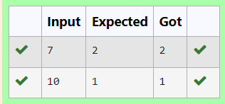

**Ex. No. : 4.9 Date: 13.04.24**

**Register No.: 231801123 Name: Pavithra S**

**Disarium Number**

A Number is said to be Disarium number when the sum of its digit raised to the power of their respective positions becomes equal to the number itself. Write a [program](https://www.rajalakshmicolleges.net/moodle/mod/quiz/view.php?id=3478) to print number is Disarium or not.

Input Format:

Single Integer Input from stdin.

Output Format:

Yes or No.

Example Input:

175

Output:

Yes

Explanation

1^1 + 7^2 +5^3 = 175

Example Input:

123

Output:

No

**For example:**

| **Input** | **Result** |
| --- | --- |
| 175 | Yes |
| 123 | No |

**Program:**

a=input()

n=len(a)

r=0

for i,d in enumerate(a):

r+=int(d)**(i+1)

if r==int(a):

print("Yes")

else:

print("No")

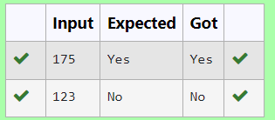

**Ex. No. : 4.10 Date: 13.04.24**

**Register No.: 231801123 Name: Pavithra S**

**Perfect Square After adding One**

Given an integer N, check whether N the given number can be made a perfect square after adding 1 to it.

Input Format:

Single integer input.

Output Format:

Yes or No.

Example Input:

24

Output:

Yes

Example Input:

26

Output:

No

**For example:**

| **Input** | **Result** |
| --- | --- |
| 24 | Yes |

**Program:**

import math

a=int(input())

b=a+1

c=math.sqrt(b)

if(c==int(c)):

print("Yes")

else:

print("No")

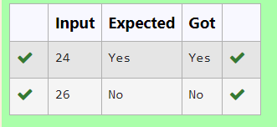

### [**05 -**](https://www.rajalakshmicolleges.net/moodle/course/view.php?id=84#section-5) **Strings in Python**

**Ex. No. : 5.1 Date: 17.04.24**

**Register No.: 231801123 Name: Pavithra S**

**String characters balance Test**

Write a program to check if two strings are balanced. For example, strings s1 and s2 are balanced if all the characters in the s1 are present in s2. The character’s position doesn’t matter. If balanced display as "true" ,otherwise "false".

**For example:**

| **Input** | **Result** |
| --- | --- |
| Yn  PYnative | True |

**Program:**

a=input()

b=input()

if a in b or b in a:

print("True")

else:

print("False")

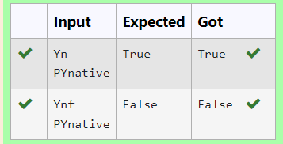

**Ex. No. : 5.2 Date: 17.04.24**

**Register No.: 231801123 Name: Pavithra S**

**Decompress the String**

Assume that the given string has enough memory. Don't use any extra space(IN-PLACE)

Sample Input 1

a2b4c6

Sample Output 1

aabbbbcccccc

**Program:**

s=input()

r=""

i=0

while i< len(s):

char=s[i]

i+=1

num=""

while i<len(s) and s[i].isdigit():

num+=s[i]

i+=1

r+=char*int(num)

print(r)

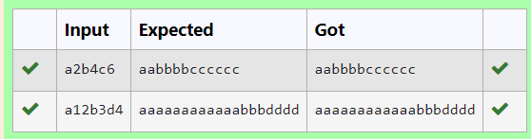

**Ex. No. : 5.3 Date: 17.04.24**

**Register No.: 231801123 Name: Pavithra S**

**First N Common Chars**

Two string values S1, S2 are passed as the input. The program must print first N characters present in S1 which are also present in S2.

Input Format:

The first line contains S1.

The second line contains S2.

The third line contains N.

Output Format:

The first line contains the N characters present in S1 which are also present in S2.

Boundary Conditions:

2 <= N <= 10

2 <= Length of S1, S2 <= 1000

Example Input/Output 1:

Input:

abcbde

cdefghbb

3

Output:

bcd

Note:

b occurs twice in common but must be printed only once.

**Program:**

a=input()

b=input()

n=int(input())

bset=set(b)

cc=[]

c=0

for i in a:

if i in bset and i not in cc:

cc.append(i)

c=c+1

if(c==n):

break

s=''.join(cc)

print(s)

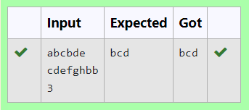

**Ex. No. : 5.4 Date: 17.04.24**

**Register No.: 231801123 Name: Pavithra S**

**Username Domain Extension**

Given a string S which is of the format USERNAME@DOMAIN.EXTENSION, the program must print the EXTENSION, DOMAIN, USERNAME in the reverse order.

**Input Format**:

The first line contains S.

**Output Format**:

The first line contains EXTENSION.

The second line contains DOMAIN.

The third line contains USERNAME.

**Boundary Condition:**

1 <= Length of S <= 100

Example Input/Output 1:

**Input**:

vijayakumar.r@rajalakshmi.edu.in

**Output**:

edu.in

rajalakshmi

vijayakumar.r

**Program:**

s=input()

at=s.index('@')

dot=s.index('.')

username=s[:at]

domain=s[at+1:dot]

exten=s[dot+1:]

print(exten)

print(domain)

print(username)

